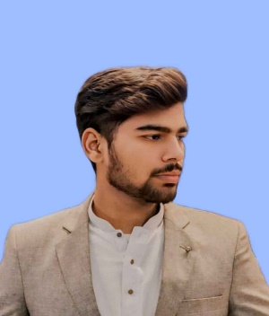
Samiullah Karamat
Phone number: +92- 3254033500
Email address: samiullahdeveloper7@gmail.com

Whatsapp: 03174919129
Home: kacha jail road, chungi amer sidhu, Lahore, Punjab 54760, Pakistan

ABOUT ME
I am a dedicated Web Developer who enjoys working with modern front-end tools. I'm skilled in using ReactJS, HTML, CSS, JavaScript, and Bootstrap. These technologies help me build websites that are not only easy to use but also visually appealing and responsive on various devices. I focus on design details and user interactions to ensure a seamless experience.

WORK EXPERIENCE

Selfemployed august 2025 - Present
Fashion frenzy “https://fashion-franzy.netlify.app/”

- Built a responsive fashion website showcasing AI-based outfit recommendations and style trends.
- Developed virtual wardrobe functionality for users to manage and combine clothing items.
- Added community features for sharing looks, challenges, and trend discussions.
- Designed a modern, user-friendly UI/UX with smooth navigation and interactive elements.

Selfemployed oct 2024 – April 2024
Nouva education /corvit

- Successfully developed and deployed multiple responsive websites across various domains.
- Implemented modern UI/UX principles to ensure engaging and user-friendly interfaces.
- Utilized latest technologies and frameworks to deliver secure, scalable solutions

EDUCATION AND TRAINING

Bachelor in Computer science:
Superior University (7th smester)

Full stack webdeveloper :
Nouva education Lahore (3 months training)

Skills

- HTML& CSS
- JAVA SCRIPT
- Firebase
- Api handling
- React Js
- MY SQL
- BOOTSTRAP
- Node Js

